005 Gulp - error handling

Gulp Kata List – Blog Page

[Gulp Kata List on GitHub](https://github.com/robertdunaway/katas-gulp)

# Duration

5 minutes

# Brief

Implement gulp-plumber for outputting errors in a readable format.

### For More Information

BING/GOOGLE: “Gulp ”

Book: <http://www.amazon.com/Gulp-Quick-guide-getting-running/dp/151468960X>

# Instructions

Get tutorial folder or the entire katas-angular2 repo.

Open the [before/*.sln] file and execute the kata.

Feel free to execute this kata multiple times because repetition creates motor memory.

# Github

* Before (start kata with this)
  + https://github.com/robertdunaway/katas-gulp/tree/master/005%20Gulp%20-%20error%20handling/before
* After
  + https://github.com/robertdunaway/katas-gulp/tree/master/005%20Gulp%20-%20error%20handling/after

# Kata

In this kata we will add plumber by piping it into a task.

First we need to install the gulp-plumber plugin.

Npm install gulp-plumber --save-dev

Now add a reference to the gulp plugin.

, plumber = require('gulp-plumber')

Add plumber to a task.

gulp.task('copy-to-wwwroot', function () {

return gulp.src(['src/**/*'])

.pipe(plumber({

errorHandler: onError

}))

.pipe(gulp.dest('wwwroot'));

});

Putting it all together you will end up with something like this.

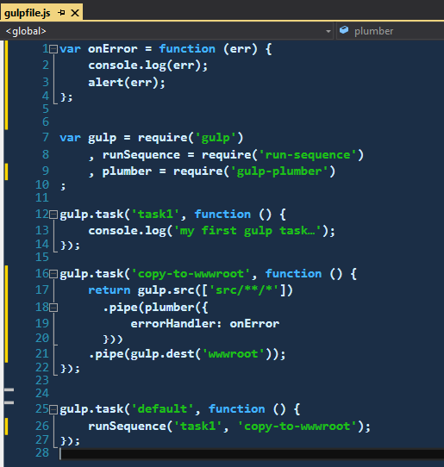

# Next

Take a few minutes and imagine more examples.